# Conflict Scenario

## **Review**

### Interpersonal Conflict Management Styles

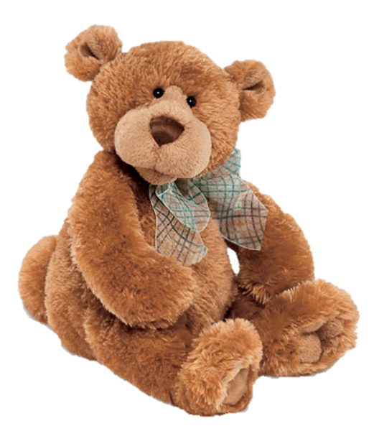

[CC 2.0 BY Matthew](https://www.flickr.com/photos/falcon1961/3304306800/)



[CC SA 3.0 Unported BY Jonathan Zander](https://en.wikipedia.org/wiki/File:Florida_Box_Turtle_Digon3.jpg)



[CC 3.0 BY Superawesomevectors](https://superawesomevectors.deviantart.com/art/Shark-Cartoon-Free-Vector-Illustration-643399222)



[CC0](https://pixabay.com/en/urban-lost-hiding-afraid-1002149/)

Low to High Concern for Other

Concern for Self



CC SA 2.0 Generic BY [Carine06 from UK](https://commons.wikimedia.org/wiki/File:Flickr_-_Carine06_-_%22I_give_up.%22.jpg)



CC 2.0 BY [Zabara Alexander](https://www.flickr.com/photos/zabara_tango/6955720271)

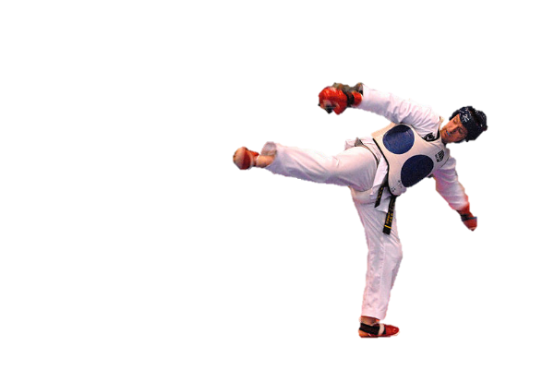

[CC0](https://commons.wikimedia.org/wiki/File:US_Army_53525_Soldiers_compete_in_Tae_Kwon_Do_tournament_for_Warrior_Country_level.jpg)

### **Interpersonal Conflict Resolution**

The following diagram shows a process that can be followed when trying to resolve interpersonal conflict.

### Listening

A considerable proportion of our communication involves listening, yet little attention is devoted to improving listening. HURIER is an acronym for tips that can be used to improve listening.

### “I” Phrases for Conflict Resolution

The “I” phrase is used during conflict resolutions to avoid attacking others. Open the conversation with a statement in first person, passive voice: “I feel … when … because … I would like …”

Adapted from (Dwyer 2012, p. 40)

## **Student Name and ID:** Hughen Flint 12177330

## **Student Name and ID:** Ujjwal Savaliya 12148197

## **Scenario**

Find a partner. Read the scenario below. Choose one partner to be Joe Bloggs, and the other to be Jane Doe. Together, answer the following to help prepare you for the role play.

## **Scenario: Joe did not complete a task by the deadline**

Joe and Jane are working on a report that is due today. Joe was assigned the task of writing the executive summary. Unfortunately, Joe has not completed the task.

What is the most appropriate conflict management strategy for Jane to use in this situation? (Choose one)

Compete/Force

Compromise

Avoid/Withdraw

Collaborate/Confront

Accommodate/Smooth

Why did you choose the above conflict management strategy?

Because both Jane and Joe must complete the task by the deadline for the due date.

### **Listen and Understand**

How could Jane start the conversation?

Hey, Joe we need to complete the task to be submitted before the due date. We should work together on this final piece.

Describe the purpose of the discussion. Describe the conflict. What questions could Jane ask to determine Joe’s perspective of the situation?

What do you think about this solution?

Do you have any other ideas?

Write sentences that features the “I” phrase, such as in the example below:

“I feel *[your feeling]* when *[their behaviour]* because *[effects on you]*. I would like *[alternative behaviour]*”.

I feel disappointed when you have not finished your part of the task because the due date is getting close, and we need the proofread still. I would like to work with you on this piece to ensure it is complete.

Invent a reason why Joe did not complete the executive summary by the deadline.

I did not manage to complete the summary because my laptop stopped working yesterday. I felt very bad for this.

How could Jane paraphrase Joe’s reason for missing the deadline to ensure that she understands Joe’s perspective?

So, you were unable to complete the summary as your laptop couldn’t function correctly?

### **Empathise**

Now that Jane understands Joe’s perspective, how could Jane empathise with Joe? Write a response that shows that Jane identifies with Joe’s emotions.

These things do happen so we can complete this together on my laptop.

### **Apologise**

Include an apology if it is appropriate.

I’m sorry about how you feel when you were unable to work on our project.

### **Offer Solution**

What question could Jane ask to help build Joe’s involvement with potential solutions?

We can work together on my laptop to complete the work before the due date.

Come up with a way for Jane and Joe to settle on a solution.

### **Resolution**

How could Jane resolve the conflict? Jane needs to ensure that Joe agrees. Write a response that outlines appreciation for the solution.

Do you like this solution?

### **Reconciliation**

How could Joe reconcile the relationship and let Jane know that she is important to him?

Yes, thank you for offering me your Laptop, Let’s finish this task if you’re free right now?

How can Jane let Joe know she is listening while Joe is talking?

Hand resting on chin, nods and clarifying by paraphrasing what Joe had said.

What could Jane do if Joe started to withdraw from the conflict at any stage?

Jane could say that this is our work and both of our responsibility to complete it before the due date. We should work on this together.